Infosys Springboard Virtual Internship 6.0 Completion Report

**PERSONAL REPORT DETAILS**

Batch Number : 10

Start date : 25-NOV-25

Names:

|  |  |
| --- | --- |
| S.NO | NAME |
| 1 | RISHWANA SIRAJUTHEEN |

Internship Duration: 8 Weeks

**1. Project Title**

INVENTRA – Intelligent Inventory Management System

**2. Project Objective**

The objective of **Inventra** is to design and implement an intelligent inventory management system that automates stock monitoring, reduces human errors, and enables data-driven decision-making for businesses. The system aims to move beyond traditional record-keeping by integrating real-time tracking, analytical insights, and smart alert mechanisms.

**Primary Objectives:**

* Automate inventory tracking and stock updates
* Provide real-time visibility of stock levels
* Detect low-stock and overstock situations
* Generate automated alerts for inventory control
* Support managerial decisions through analytical dashboards
* Develop a scalable solution suitable for retail and warehouse environments

**3. Project description in detail**

**Inventra – Intelligent Inventory Management System** is a full-stack software solution designed to monitor, manage, and optimize inventory operations in a structured and automated manner. The system reduces manual effort, prevents stock shortages, and improves decision-making through real-time tracking and intelligent alerts.

The system is built using **Java** for backend services, **React.js** for the interactive web dashboard, and **MySQL** for reliable and structured data storage. Inventra ensures accurate stock monitoring, secure data handling, and efficient inventory control through four major functional modules.

**System Modules**

**Module 1: Authentication Module**

This module ensures secure access to the system.  
It manages user login, registration, and role-based access control.

**Key Functions:**

* User account creation and login validation
* Secure password storage and authentication
* Role management (e.g., Admin, Staff)
* Session handling to protect system access

**Purpose:**  
Prevents unauthorized usage and ensures only verified users can manage inventory data.

**Module 2: Product Management Module**

This module handles all operations related to inventory items.

**Key Functions:**

* Add new products with details (name, category, quantity, supplier)
* Update existing product information
* Delete or deactivate outdated products
* View product lists and current stock levels

**Purpose:**  
Maintains an organized and up-to-date record of all inventory items in the system.

**Module 3: Alert & Monitoring Module**

This is the intelligent monitoring part of the system that tracks stock levels continuously.

**Key Functions:**

* Define minimum stock threshold for each product
* Automatically detect low-stock conditions
* Generate alerts and notifications for restocking
* Display warning indicators on the dashboard

**Purpose:**  
Helps prevent stockouts and ensures timely replenishment of inventory.

**Module 4: Transactions Module**

This module records all stock movements to maintain accurate inventory counts.

**Key Functions:**

* Record stock additions (purchases/restocking)
* Record stock reductions (sales/usage)
* Maintain transaction history with timestamps
* Automatically update stock levels after each transaction

**Purpose:**  
Provides traceability of inventory flow and ensures real-time accuracy of stock data.

**Overall System Outcome**

By integrating these four modules, Inventra delivers:

* Real-time inventory visibility
* Reduced manual tracking errors
* Automated low-stock alerts
* Structured transaction history
* Efficient stock management and planning

**4. Timeline Overview**

|  |  |  |
| --- | --- | --- |
| **Week** | **Work Planned** | **Work Completed (Individual Contribution)** |
| **Week 1** | Requirement analysis and problem identification | Studied real-world inventory management issues, defined the project scope, and finalized system objectives |
| **Week 2** | System design and database planning | Designed the overall system architecture and created the database schema for products, stock, and transactions |
| **Week 3** | Development of Product Management module | Implemented features to add, edit, delete, and display product information in the system |
| **Week 4** | Development of Transaction Management module | Developed sales and purchase entry modules with automatic stock quantity updates |
| **Week 5** | Stock Monitoring and Alert implementation | Created logic to continuously monitor stock levels and generate low-stock alerts based on threshold values |
| **Week 6** | Analytics Dashboard development | Designed and implemented dashboards to visualize stock trends, product movement, and inventory summaries |
| **Week 7** | System integration and testing | Integrated all modules, tested system functionality, fixed bugs, and ensured accurate real-time updates |
| **Week 8** | Documentation and final deployment preparation | Prepared the final report, optimized system performance, and completed the project presentation setup |

**5a. Key Milestones**

|  |  |  |
| --- | --- | --- |
| **Milestone** | **Description** | **Date Achieved** |
| **Project Kickoff** | Initial project briefing, objective finalization, system architecture planning, and research on advanced sentiment analysis and intelligent recommendation techniques. | **25-NOV-25** |
| **Prototype / First Draft** | Completion of dataset collection, preprocessing pipeline setup, feature engineering, and development of the initial sentiment analysis and recommendation model prototype. | **20-DEC-25** |
| **Mid-Term Review** | Evaluation of model performance using validation metrics, refinement of algorithms, dashboard framework design, and review of system progress with improvement planning. | **10-JAN-26** |
| **Final Submission** | Completion of optimized model training, integration with dashboard/interface, backend connectivity, system testing, and full technical documentation. | **10-FEB-26** |
| **Presentation** | Final project demonstration highlighting sentiment insights, recommendation outputs, system workflow, and complete dashboard functionality. | **25-FEB-26** |

**5b. Project execution details**

• The **Inventra – Intelligent Inventory Management System** was developed using a structured full-stack software engineering approach focused on real-time monitoring and intelligent stock management. The project began with requirement analysis, system objective definition, and architecture planning for an automated inventory tracking solution. Core technologies selected included **Java** for backend development, **React.js** for the interactive frontend dashboard, and **MySQL** for structured data storage. A milestone-driven development strategy ensured smooth implementation and validation at each stage.

• The backend system was built using Java-based RESTful services to handle inventory data processing, user authentication, and system logic. APIs were designed to support product addition, stock updates, transaction logging, and alert generation. Data validation and business rules were implemented at the server level to maintain consistency and prevent stock anomalies.

• The database layer was designed in MySQL with normalized tables for products, stock levels, transactions, suppliers, and alert records. Efficient queries and indexing strategies were applied to ensure fast retrieval of inventory data and historical transaction logs. This enabled accurate tracking of stock inflow, outflow, and current availability.

• Intelligent monitoring features were incorporated to track stock thresholds and usage patterns. The system automatically generated alerts when inventory levels dropped below predefined limits, helping administrators take timely restocking actions. Historical data analysis supported basic demand trend observation to improve inventory planning.

• A responsive web dashboard was developed using React.js to provide administrators with real-time visibility of inventory status. The interface displayed stock summaries, low-stock alerts, transaction history, and product management controls. Interactive components and dynamic data updates ensured a smooth and user-friendly experience.

• System integration involved connecting the React frontend with Java backend APIs and the MySQL database. End-to-end testing, including unit testing and functional validation, was performed to ensure reliable operation. The final system was prepared for deployment with proper documentation, database backup strategies, and scalability considerations for future enhancements.

**Inventory System Workflow**

1. **UserLogin**  
   The user logs into the system using valid credentials.
2. **Add/Manage Product**  
   The user adds a new product or updates existing product details such as name, category, and quantity.
3. **Record Transaction (Sale/Purchase)**  
   When a sale or purchase occurs, the user records the transaction in the system.
4. **Automatic Stock Update**  
   The system automatically increases or decreases the stock quantity based on the transaction type.
5. **Stock Level Check**  
   After updating, the system checks whether the product quantity has fallen below the predefined minimum stock level.
6. **Low-Stock Alert Generation**  
   If stock is below the threshold, the system generates a low-stock alert and displays a warning on the dashboard.
7. **Admin Action**  
   The administrator reviews alerts and takes necessary restocking action.

**6. Snapshots / Screenshots**

**MODULE 1: AUTHENTICATION MODULE**

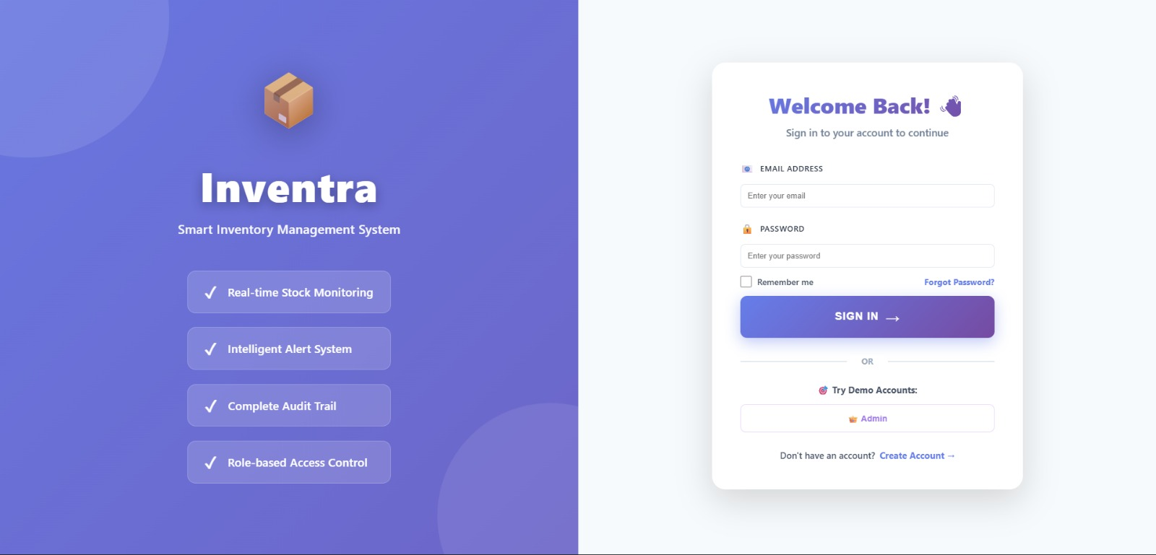

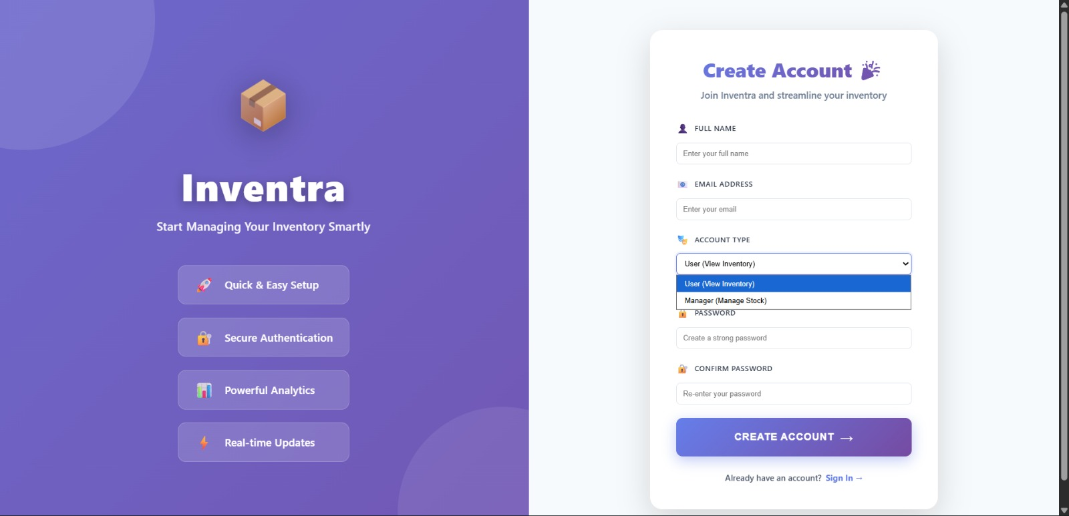

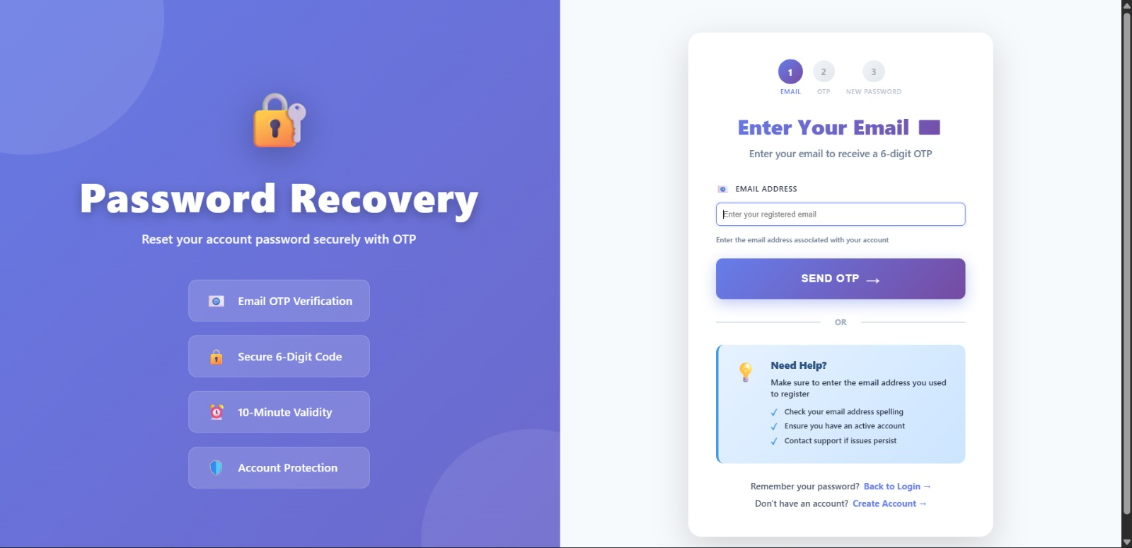

**MODULE 2: PRODUCT DESIGN MODULE**

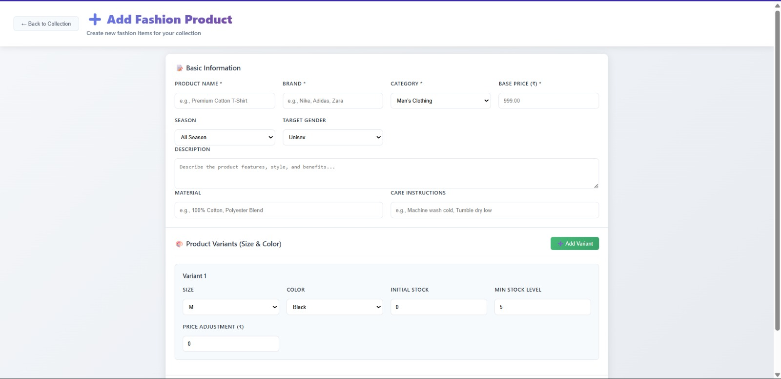

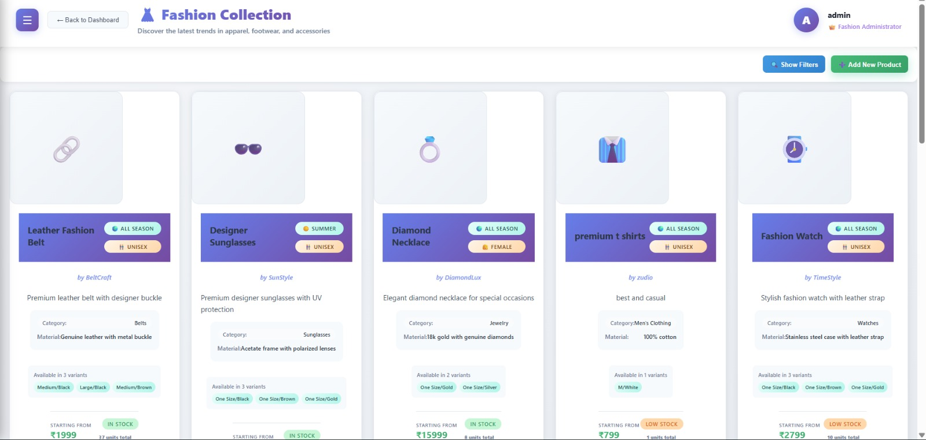

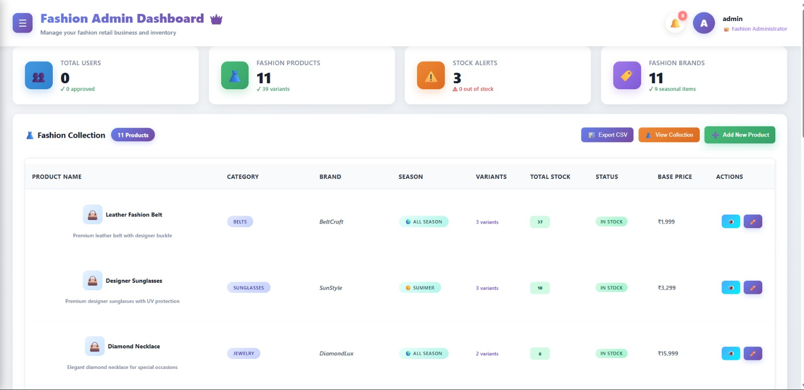

**MODULE 3: ALERT MODULE**

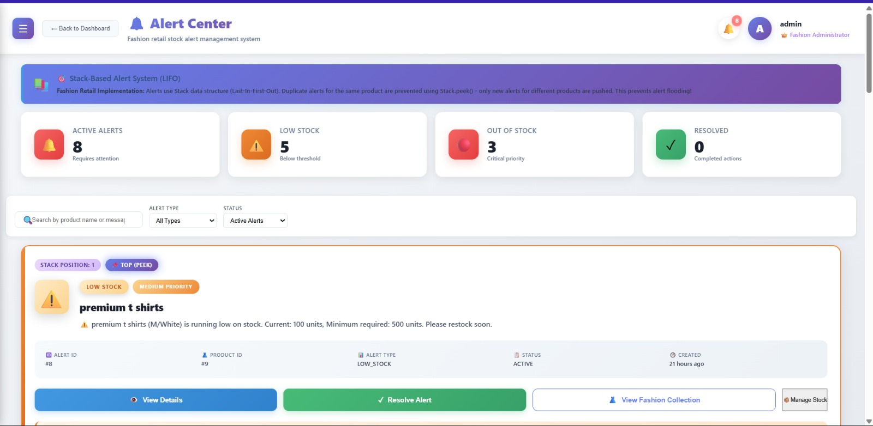

**MODULE 4 :TRANSACTION MODULE**

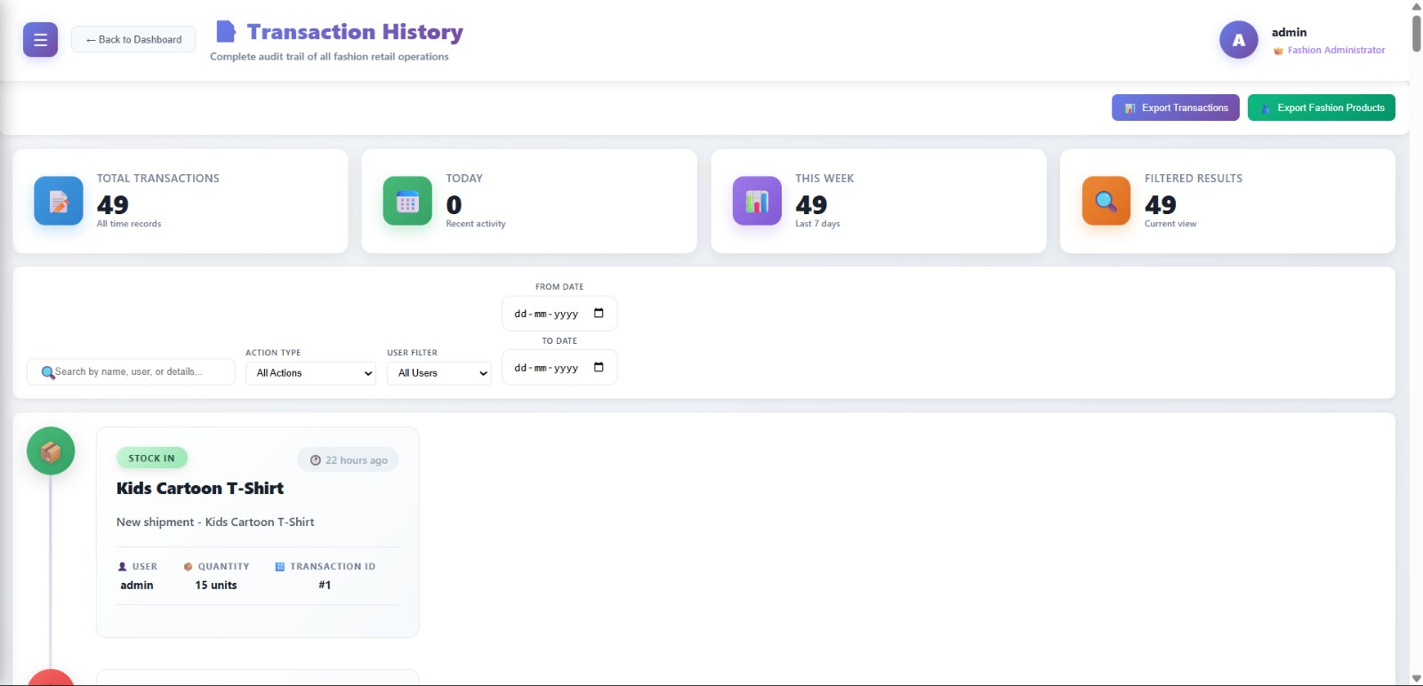

**RBAC(Role Based Access Control)**

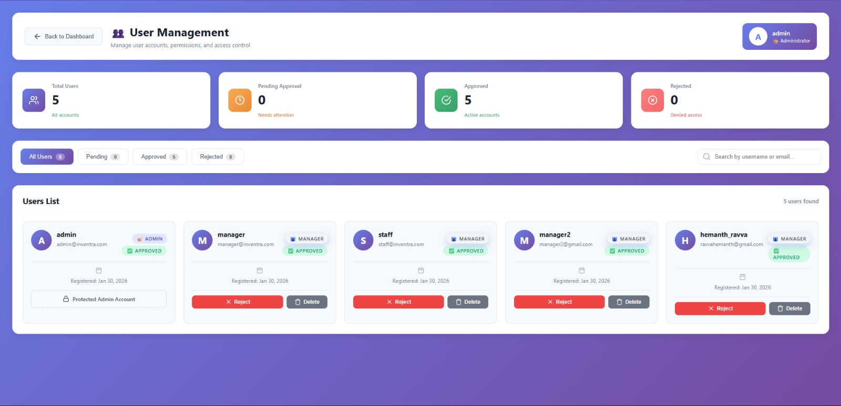

**7. Learnings & Skills Acquired**

**Full-Stack Development –** I gained practical experience in developing a complete web-based system using Java for backend logic and React.js for frontend interface design.

**Backend API Development –** I learned to design and implement RESTful APIs to handle product management, stock updates, user authentication, and transaction processing.

**Database Design & Management –** I developed skills in designing normalized MySQL database schemas, writing efficient queries, and managing relationships between products, transactions, and users.

**Authentication & Security –** I understood how to implement secure login systems, password protection, and role-based access control to restrict unauthorized system usage.

**Inventory Logic Implementation** – I gained hands-on experience in creating business logic to automatically update stock quantities based on sales and purchase transactions.

**Alert & Monitoring Systems** – I learned to implement threshold-based stock monitoring that generates alerts when inventory levels fall below predefined limits.

**Frontend Dashboard Development –** I built interactive dashboards using React.js to display stock summaries, low-stock alerts, and transaction history in a user-friendly format.

**System Integration –** I learned how to connect frontend components with backend APIs and integrate them with a MySQL database for real-time data updates.

**Testing & Debugging –** I improved my ability to test backend functions, validate system workflows, and debug integration issues between modules.

**Project Planning & Documentation –** I developed skills in structuring modules, documenting system design, and presenting technical workflows clearly.

**8. Challenges Faced**

**Challenge 1: Designing an Efficient Database Structure**

**Problem:**  
Organizing product, stock, supplier, and transaction data without redundancy while maintaining fast retrieval.

**Solution:**  
Designed a normalized **MySQL** database schema with proper relationships, indexing, and optimized queries to ensure accurate and efficient data handling.

**Challenge 2: Maintaining Real-Time Stock Accuracy**

**Problem:**  
Ensuring stock levels update correctly after every sale or purchase without mismatches.

**Solution:**  
Implemented backend business logic in **Java** to automatically adjust inventory quantities during each transaction and validate stock availability before processing.

**Challenge 3: Implementing Low-Stock Alert Mechanism**

**Problem:**  
Tracking inventory levels continuously and identifying when stock drops below the minimum threshold.

**Solution:**  
Developed a threshold-based monitoring system that checks stock levels and generates automatic alerts displayed on the dashboard.

**Challenge 4: Backend–Frontend Integration**

**Problem:**  
Ensuring smooth communication between the React frontend and Java backend APIs without data inconsistencies.

**Solution:**  
Used RESTful APIs with proper request/response handling, JSON formatting, and error handling to maintain reliable data flow.

**Challenge 5: User Authentication & Data Security**

**Problem:**  
Preventing unauthorized access and protecting sensitive inventory data.

**Solution:**  
Implemented secure login validation, password protection, and role-based access control to restrict system functionality based on user roles.

**Challenge 6: Handling Large Transaction Records**

**Problem:**  
Managing and displaying growing transaction history without slowing down the system.

**Solution:**  
Optimized database queries, added indexing, and implemented pagination in the React dashboard to load data efficiently.

**9.Testimonials (Individual Experience)**

As part of my internship journey, I explored new technologies and applied industry-style development practices while building the Inventra Inventory Management System. Despite balancing academic responsibilities, I maintained consistent progress by planning tasks effectively and meeting weekly milestones. I documented implementation steps, resolved technical challenges independently, and continuously improved my problem-solving approach. This experience strengthened my ability to work in a structured development environment and enhanced my practical understanding of full-stack system design.

**10. Real-World Impact of Inventra**

Inventra is not just an academic project but a practical solution that can be applied in small businesses, retail stores, pharmacies, and warehouses. By automating stock tracking and alert generation, the system reduces manual errors, prevents stock shortages, and improves inventory visibility. This leads to better decision-making, reduced operational delays, and improved customer satisfaction. The project demonstrates how software systems can solve everyday business problems efficiently.

**11. Future Enhancements**

Although Inventra provides core inventory management features, several enhancements can make the system more advanced:

* Barcode or QR code scanning for faster product entry
* Role-based dashboards for Admin, Staff, and Managers
* Predictive stock demand using sales history
* Email/SMS notifications for low-stock alerts
* Mobile app version for remote inventory access
* Cloud deployment for multi-branch inventory tracking

**12. Key Technical Highlights**

* RESTful backend architecture using Java
* Normalized relational database design in MySQL
* Real-time stock updates using transaction-based logic
* Threshold-driven alert system
* Interactive React dashboard with dynamic data rendering
* Secure authentication and role-based access

**13. System Limitations**

* Currently designed for single-branch inventory
* Alerts are dashboard-based (no SMS/email yet)
* No predictive analytics in the current version
* Requires manual product data entry

**14. Conclusion**

The Inventra – Intelligent Inventory Management System provided me with a complete end-to-end software development experience covering requirement analysis, system design, backend development, frontend integration, database management, testing, and deployment planning. Through this project, I strengthened my technical skills in Java, React, and MySQL while gaining practical knowledge of inventory logic, API development, and dashboard visualization. Overall, this internship project played a significant role in improving my technical confidence and industry readiness, marking an important milestone in my journey toward becoming a skilled software engineer.

**15. Acknowledgements**

I would like to express my sincere gratitude to my mentor for providing continuous guidance, encouragement, and technical support throughout this internship. Your insights and feedback helped me improve my understanding of system design and implementation. I am also thankful for the learning opportunity that allowed me to work on a real-world project and enhance my practical skills. This experience has been invaluable in shaping my professional growth.

Virtual Internship 6.0 